8)Network Virtualization – OpenVSwitch and Linux bridge
Aim:
To perform network virtualization in Linux using OpenVswitch and Linux Bridge.
OpenVswitch
OpenVSwitch (OVS) is an open-source, production-quality, multi-layer software switch designed for virtualized environments, particularly in Linux-based hypervisors. It provides virtual network connectivity to virtual machines (VMs) and serves as a foundational component in modern data centers and software-defined networks (SDNs). OVS enables network automation through programmatic extensions like the OpenFlow protocol and the OVSDB management protocol, while also supporting standard network management interfaces such as NetFlow, sFlow, and LACP
Linux bridge
A Linux bridge is a software-based network device that functions like a physical network switch, allowing multiple network interfaces (physical or virtual) to be connected and operate as a single logical network segment. It works at the data link layer (Layer 2), forwarding network traffic based on MAC addresses rather than IP addresses. Linux bridges are crucial for virtual networking, enabling virtual machines and containers to communicate with each other and with the physical network, and are often used to create isolated networks or connect different network segments

PROCEDURE:
Linux Bridge:
- Check the current network configuration.
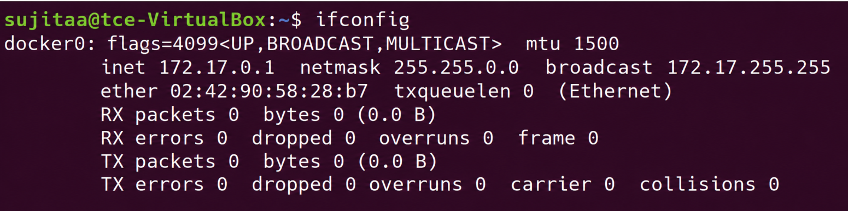
- Install and configure necessary Bridge Utilities
  - Install bridge-utils
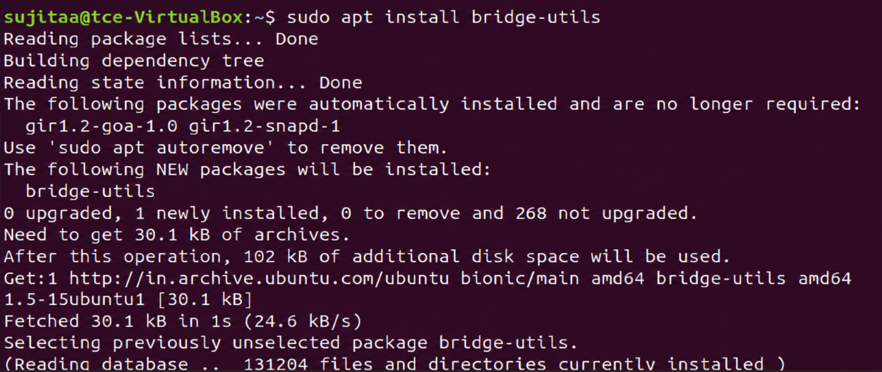
  - Load loads the bridge kernel module, which is required for bridge functionality.
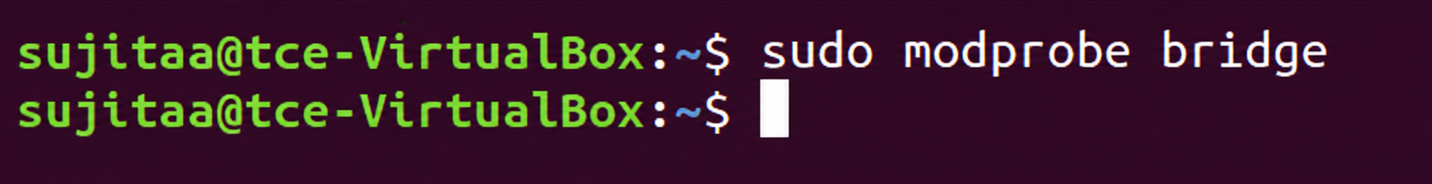
  - Loads the br_netfilter kernel module, which enables netfilter (firewall) rules to be applied to traffic passing through the bridge.
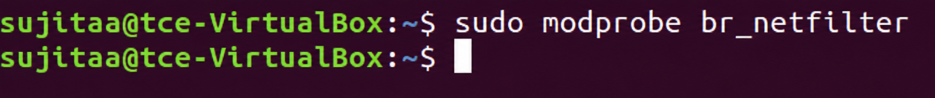
- Edit the netplan configuration file and specify the configuration.
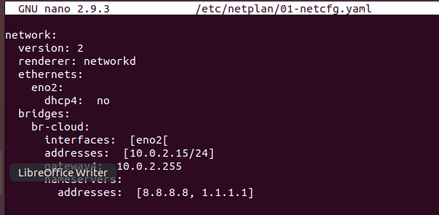
- Apply the new netplan configuration and restart the network.
- Verify the network interfaces and bridges
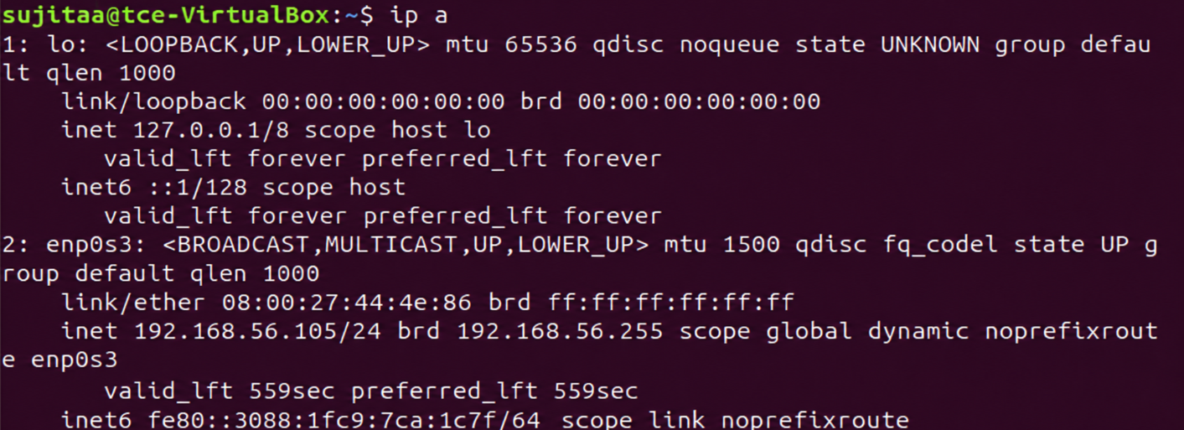
- Verify the routing table.
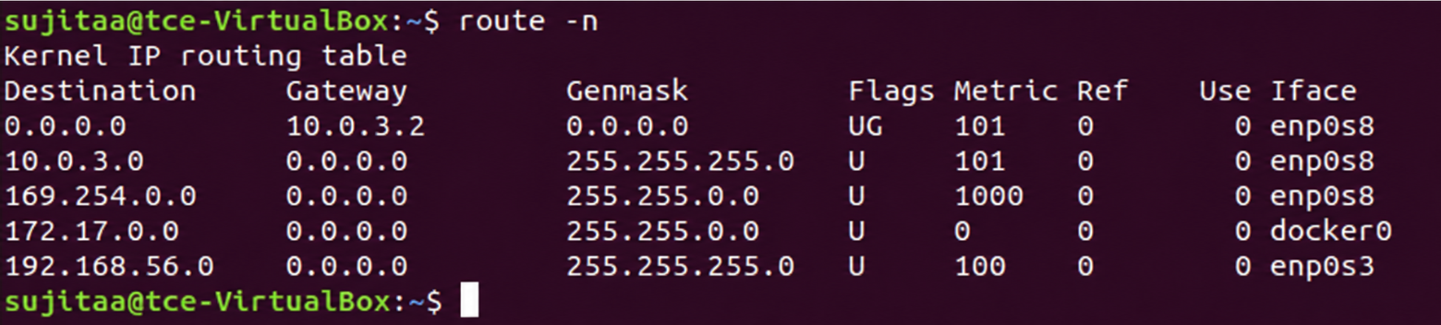
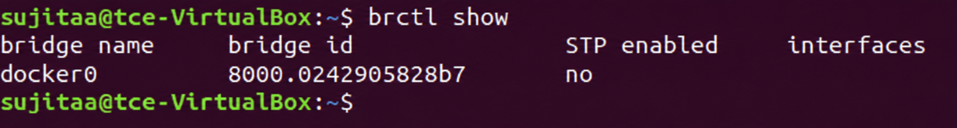

Open Virtual Switch (OpenVSwitch/OVS):
- Enter as root user.
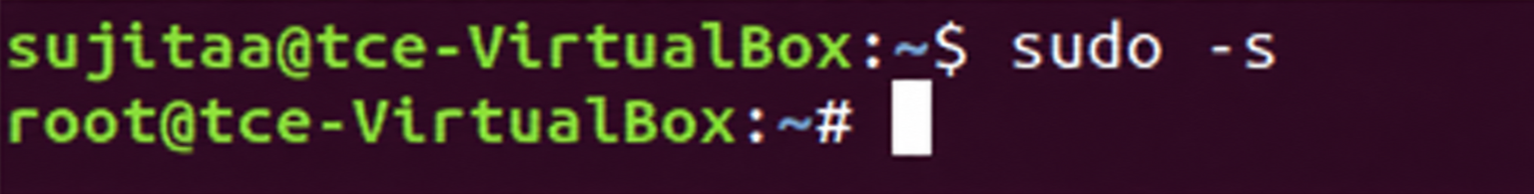
- Create 2 namespace (in my case VRF1 and VRF2)
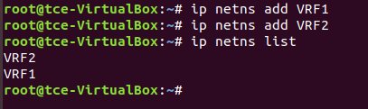
- Create 4 Virtual ethernet port to attach with bridge and namespaces.
Similarly add veth3 and veth4.
- If the configuration is done to create the topology shown in the image, the links will be as
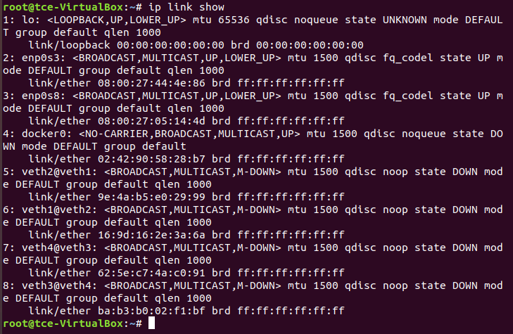
- Assign each virtual ethernet port to the particular namespace
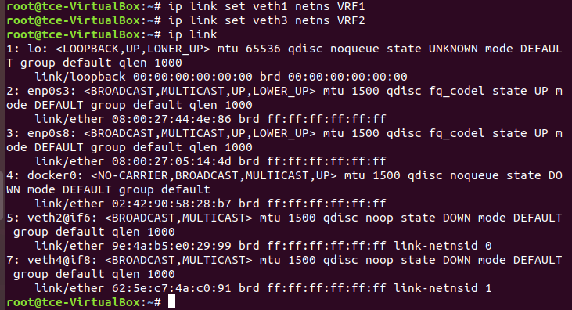
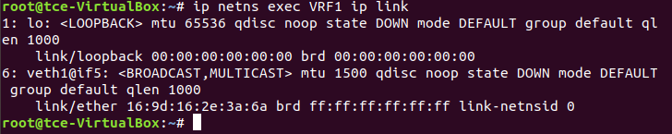
You can see that veth1 port is attached to the VRF1 namespace.
- Assign IP addresses to the virtual ethernet ports

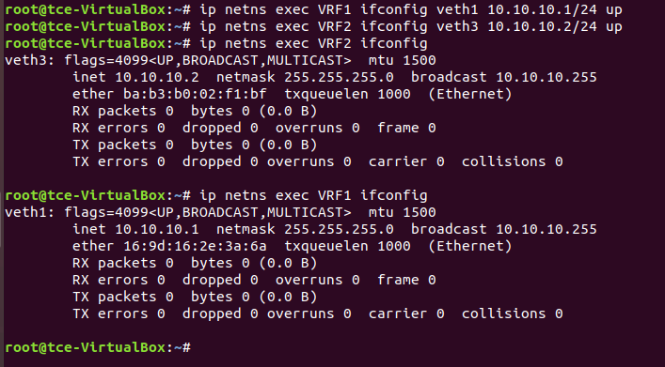
- Check the configuration using the default routing table
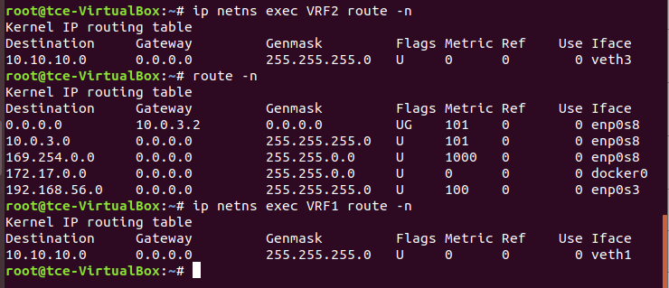
- Install openVswitch and its dependencies
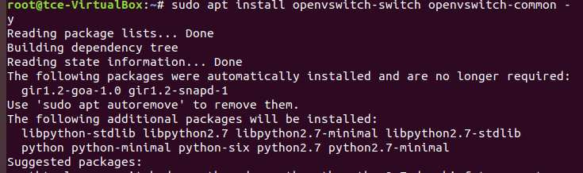
- Check the status of the openvswitch service, if off turn it on.
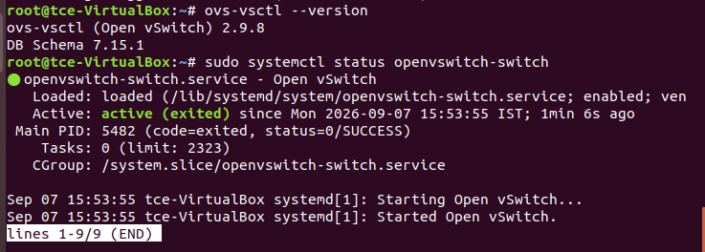
- Add the switch using ovscommandline tools and check the configuration
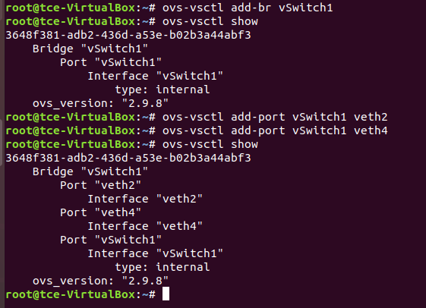
- Turn the virtual ethernet ports up and configure IP for switch check their status
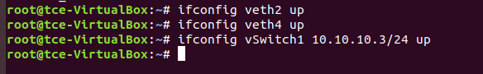
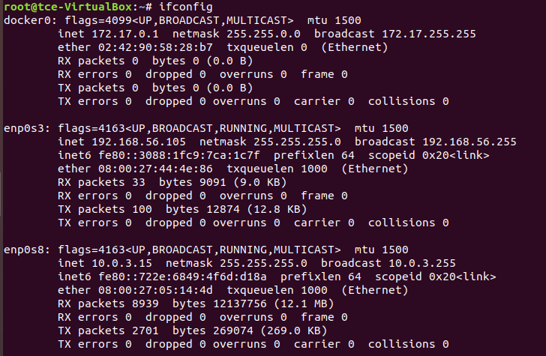
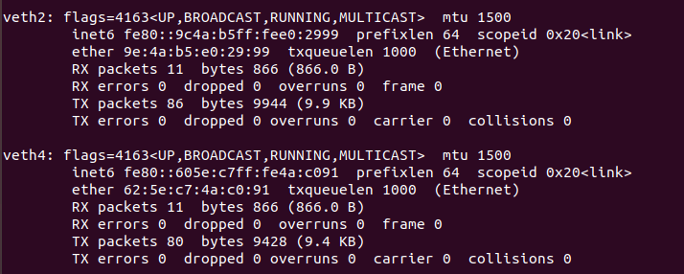
- Ping the namespace at the other end, if the configuration is done correct we can ping the Virtual namespace 2 from virtual namespace 1 via the switch (ovs bridge)
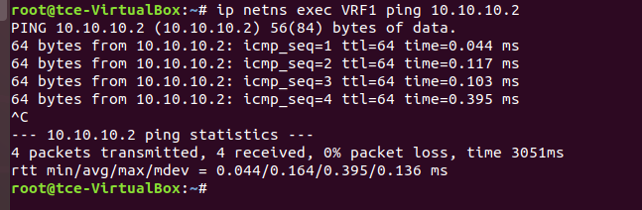
- Optionally you can turn on the spanning tree protocol (to prevent broadcast storms and network loops)
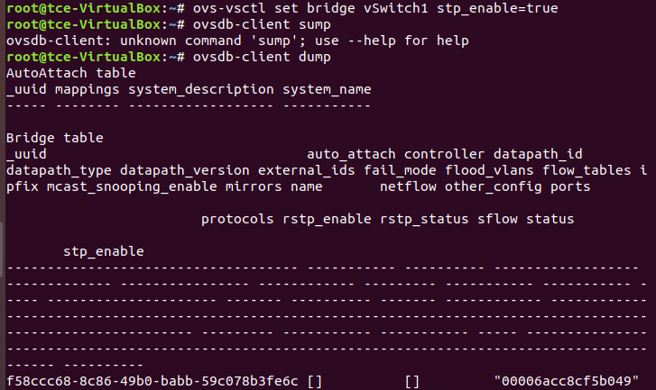

- Finally check the MAC address attached with the switch and the actual mac address of the virtual namespace device, if they match everything is done right.
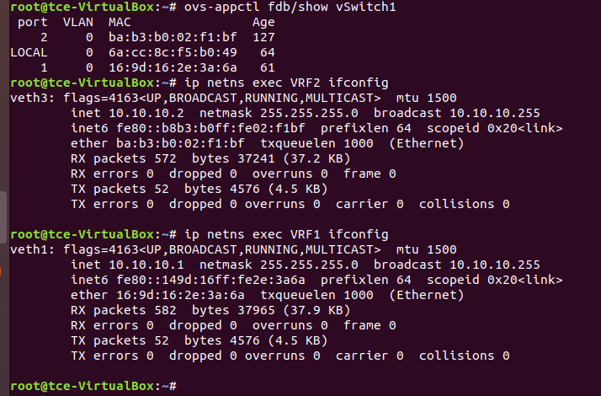

Result:
Thus, we have performed OpenVswitch and Linux Bridge successfully.

